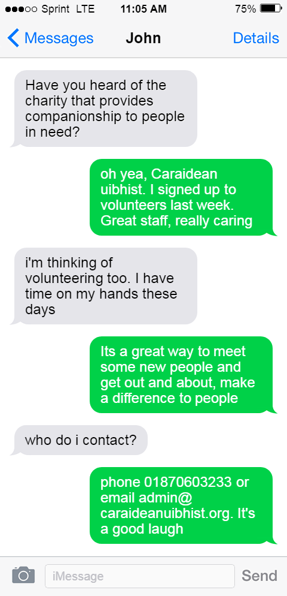

**Caraidean Uibhist**

Be the positive change in our community

**Caraidean Uibhist**

Be the positive change in our community

Contact us on **01870 603233**

**Volunteers Needed**

Contact us on **01870 603233**

**Caraidean aims to provide support and enrichment to anyone that finds themselves isolated or lonely for whatever reason. The benefits of regular social interaction cannot be over stated and we are looking to recruit community members to help bring the laughter and joy back to people who need it.**

